Magnetometer Block

ECE441 Wearable Sensor for the Blind Project

Jacy Barr

ECE Senior Design

Oregon State University,

Corvallis, OR USA

barrja@oregonstate.edu

# Introduction

The purpose of this document is to describe the Magnetometer block of the ECE441 Wearable Sensor for the Blind project so fellow 4th year ECE students will be able to reproduce and verify this components functionality without further research. The magnetometer block is implemented using a SEN12670 triple axis magnetometer breakout board with a MAG3110 IC. This document provides an overview of the overall block function including interface properties and a schematic, verification for the design in the form of a step-by-step testing process, and support for the validity of the design in the form of outside research and numerical justification addressing individual properties.

# Block Overview

The SEN12670 breakout board for this block detects three axes (xyz) of surrounding magnetic fields to determine orientation with respect to the magnetic north and south poles. This polled information is relayed back to a microcontroller via I2C communication to align head mounted sensors with waist mounted vibrations motors. The block must be capable of sensing the earth’s magnetic field orientation and outputing data over I2C to communicate this data back to the microcontroller. Fig. 1 shows the black box diagram. The block is powered from the **pwr_spply_mgnmtr_dcpwr** interface from a 3.3V source with a nominal current draw of 5uA during standby mode. Communication to the magnetometer will be via I2C over the **cntrllr_cd_mgntmr_data** interface while proccessed data from the magnetometer will be sent over the **cntrllr_cd_hptc_fdbck_**data interface. Finally, the environmental magnetic fields is measured in terms of flux density with respect to each axes which is represented by the **otsd_mgntmtr_envin** interface. The full listing of interface properties are listed below in Table 1.

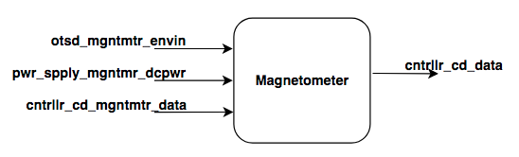

1. Black Box Diagram of Display Block
2. Display Block Interfaces and Properties

| Interface | Properties |
| --- | --- |
| **otsd_mgntmtr_envin** | 1. Direction Measurement Accuracy: 15°  2. Minimum Magnetic Flux Density: -1mT  3. Maximum Magnetic Flux Density: 1mT  4. Magnetic Flux Density Resolution: 1µT |
| **pwr_spply_mgntmr_dcpwr** | 1. Min Voltage: 1.95V  2. Max Voltage: 3.6V  3. Nominal Current: 5µA (standby)  4. Peak Current: 0.5mA (measurement) |
| **cntrllr_cd_mgntmtr_data** | 1. Protocol: I2C  2. Data Rate: 112.5kHz  3. Messages: Address Programming, Measurement Trigger, Measurement Read  4. Other: Measurement Frequency: 20Hz |
| **cntrllr_cd _data** | 1. Protocol: I2C  2. Data Rate: 112.5kHz  3. Messages: Sensor Data  4. Other: Measurement Frequency: 20Hz |

# Verification

Based on the interfaces for this block, a verification (testing) process needs to be indicated. This will allow for the final constructed design to be tested verifying that all of the interface properties have been met and that the block is ready for integration into the system.

## Environment Testing

PASS:

[**Link to Video**](https://youtu.be/z8ibpUJ79lo)

## Power Testing

PASS:

[**Link to Video**](https://www.youtube.com/watch?v=z4GEiELODtY)

## Communication Testing

PASS:

[**Link to Video**](https://youtu.be/1DMSywgpWQM)

If the block passes all of the listed tests, all interface properties have been verified and the block is ready for inclusion into the system.

# Design

The Wiring Diagram (Fig. 2) presents the block design, including the interfaces of the block. These interfaces are further elaborated through validation information given in Table 2, which demonstrates externaly-supported validy for each of the block’s properties.

## Wiring Diagram

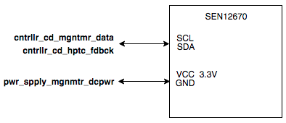

1. Wiring Diagram for the Display Block

## Design Validation

Table 2 includes the interface property validation for this block. All interface properties have been addressed and the design meets or exceeds the properties.

1. Interface Property Validation for the DIsplay Block

| Property | Validation |
| --- | --- |
| **otsd_mgntmtr_envin** |  |
| 1.Direction Measurement Accuracy: 15° |  |
| 2.Minimum Magnetic Flux Density: -1mT |  |
| 3.Maximum Magnetic Flux Density: 1mT |  |
| 4.Magnetic Flux Density Resolution: 1µT |  |
| **pwr_spply_mgntmtr_dcpwr** |  |
| 1.Min Voltage: 1.95V |  |
| 2.Max Voltage: 3.6V |  |
| 3.Nominal Current: 5µA (standby) |  |
| 4.Peak Current: 0.5mA (measurement) |  |
| **cntrllr_cd_mgntmre_data** |  |
| 1.Protocol: I2C |  |
| 2.Data Rate: 112.5kHz |  |
| 3.Messages: Address Programming, Measurement Trigger, Measurement Read |  |
| 4.Other: Measurement Frequency: 20Hz |  |
| **mgntmtr_cntrllr_cd_data** |  |
| 1.Protocol: I2C |  |
| 2.Data Rate: 112.5kHz |  |
| 3.Messages: Sensor Data |  |
| 4.Other: Measurement Frequency: 20Hz |  |

# Bill of Materials

# References